Microsoft Entra PIM vs.
Privileged Access Management (PAM)
Why Organizations May Need Both for Comprehensive Privileged Access Security

Prepared by | Adnan Ahmed
Date | September 2026
Document type | Technical Guidance / Privileged Access
Purpose | Practical comparison of Microsoft Entra PIM and PAM controls

Internal technical guidance – screenshots should remain fully redacted before publication or distribution.

Executive Summary
Organizations that have invested heavily in Microsoft identity and security capabilities often ask a reasonable question: “If we already have Microsoft Entra Privileged Identity Management (PIM), why do we need a separate Privileged Access Management (PAM) capability?”
PIM and PAM address related but different privileged-access risks. Microsoft Entra PIM is designed primarily to govern when an identity receives privileged authorization. It supports eligible assignments, just-in-time activation, time-bound access, multifactor authentication requirements, justification, approval workflows, and auditing for privileged roles.
PAM addresses another layer of the privileged-access lifecycle: the privileged account, password, or secret itself. Depending on the platform and configuration, PAM can vault privileged credentials, restrict access to individual secrets, require credential checkout, automatically rotate passwords, manage shared or service accounts, track dependencies, and maintain credential-level audit trails.
Key distinction: PIM controls when an identity receives privilege. PAM controls how privileged credentials and accounts are secured, used, rotated, and audited.
The walkthrough below uses observed functionality from Microsoft Entra PIM and a PAM environment to demonstrate why the two technologies can be complementary rather than redundant.

1. The Privileged Access Problem
Privileged access is no longer limited to administrators signing into systems with highly privileged user accounts. Modern environments contain several forms of privilege, including:
- Microsoft Entra administrative roles
- Azure resource permissions
- On-premises administrative accounts
- Shared privileged accounts
- Service accounts
- Application identities and service principals
- Automation credentials
- Secrets and passwords used by applications or services
This creates two separate security questions. First: who should be authorized to become privileged, under what conditions, and for how long? This is a core problem that PIM solves. Second: how should privileged credentials and accounts themselves be stored, controlled, rotated, checked out, and audited? This is a core problem that PAM solves.

2. What Microsoft Entra PIM Provides
Microsoft Entra Privileged Identity Management provides just-in-time and time-bound governance of privileged access. Instead of maintaining standing administrative privilege indefinitely, an organization can make an administrator eligible for a role and require activation when the privilege is actually needed.

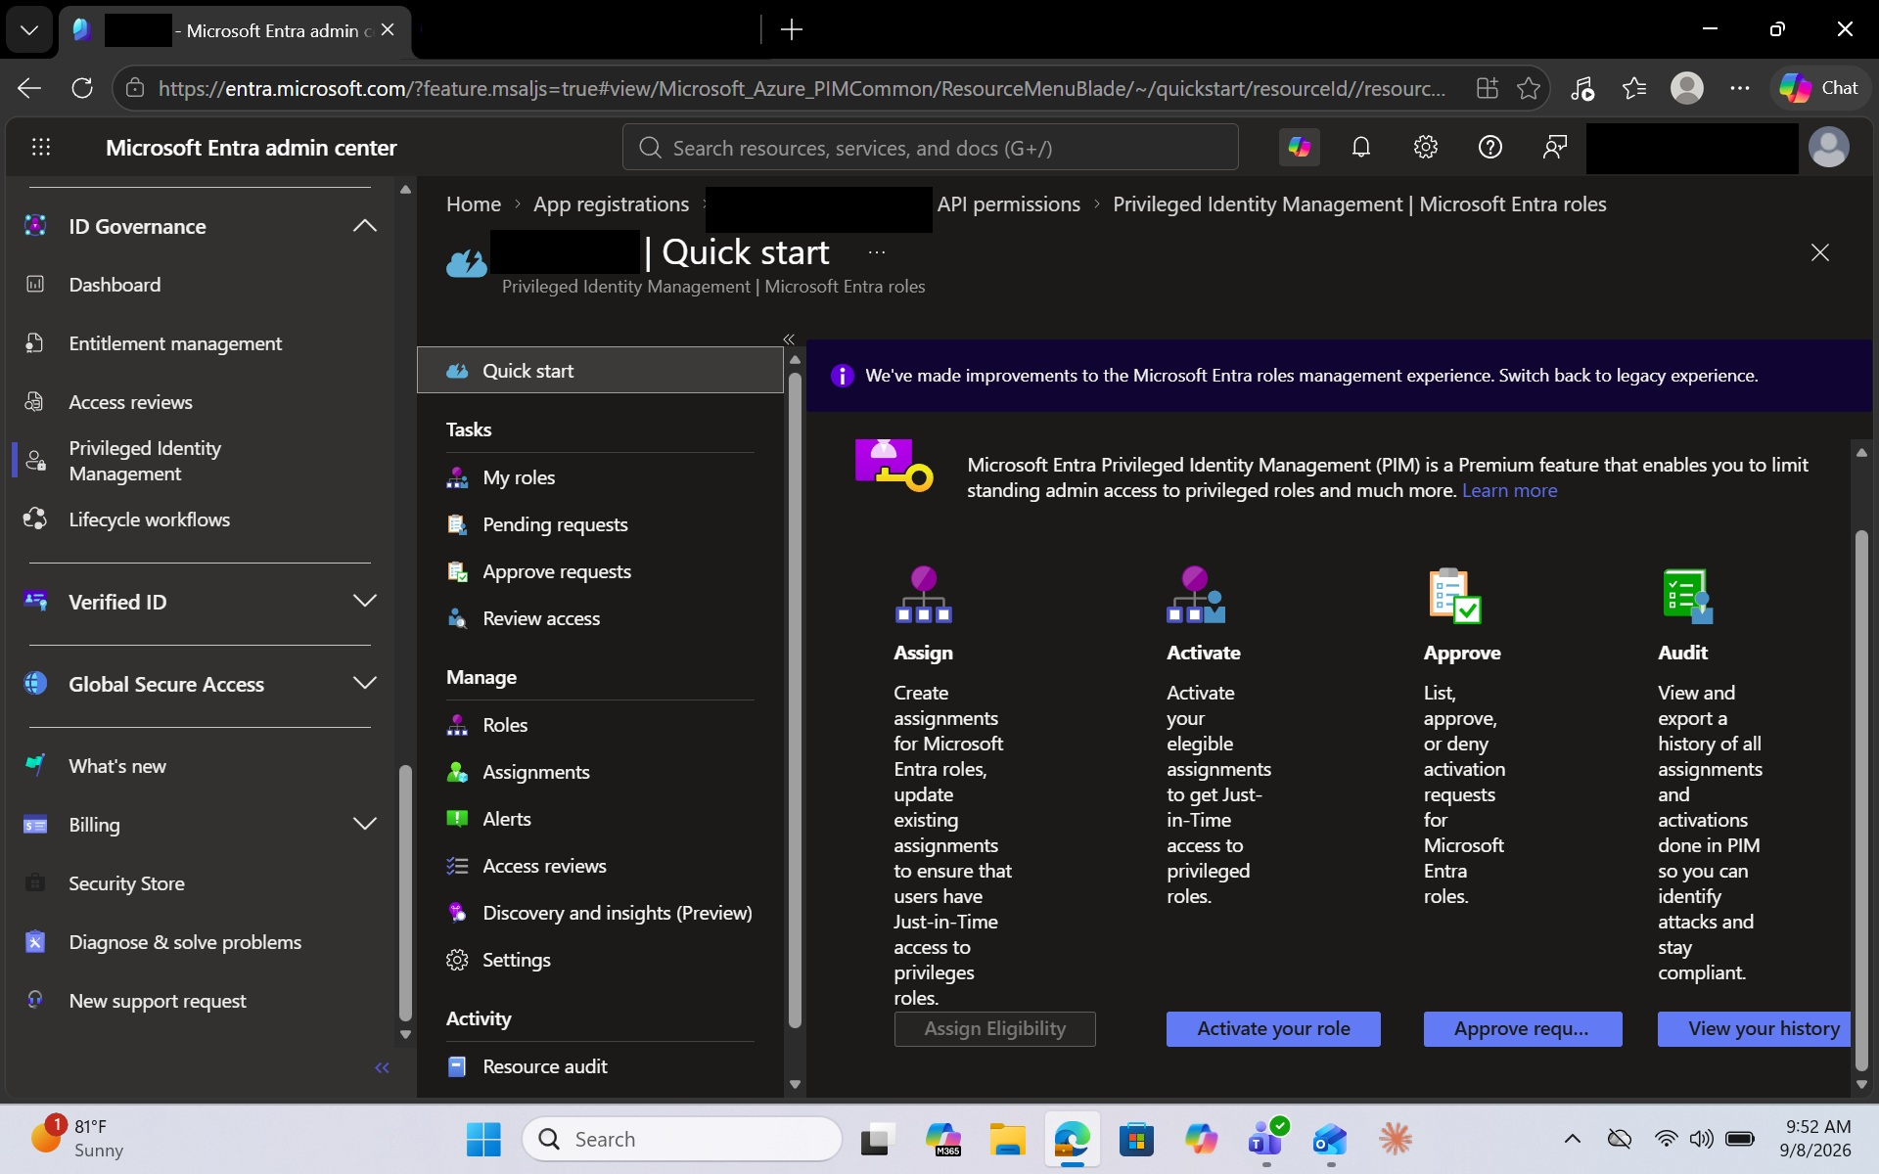

Figure 1 – Microsoft Entra Privileged Identity Management overview

Figure 1 illustrates the primary privileged-role lifecycle available through Microsoft Entra PIM. Administrators can assign privileged eligibility, activate eligible roles when needed, implement approval processes, and audit privileged-role activity. This demonstrates that PIM is fundamentally designed around controlling the assignment and activation of privilege.

PIM also allows for a “pass wordless” environment. Where the password for the task at hand is irrelevant if logged in properly with current work account.

3. Eligible vs. Active Privileged Access
One of PIM's most important security capabilities is the distinction between eligible and active assignments. An eligible administrator does not necessarily possess the privileges of the role continuously; the administrator activates the eligible assignment before using it. This reduces unnecessary standing administrative access.
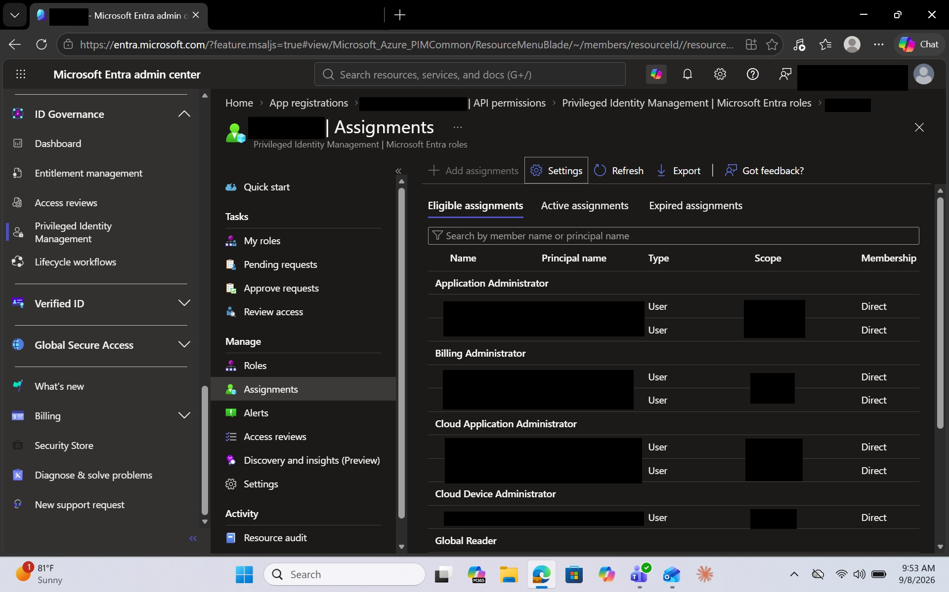
Figure 2 – Eligible privileged-role assignments in Microsoft Entra PIM
Figure 2 demonstrates privileged roles configured as eligible assignments. Eligibility allows an identity to receive privileged authorization only when required rather than maintaining continuous active privilege.

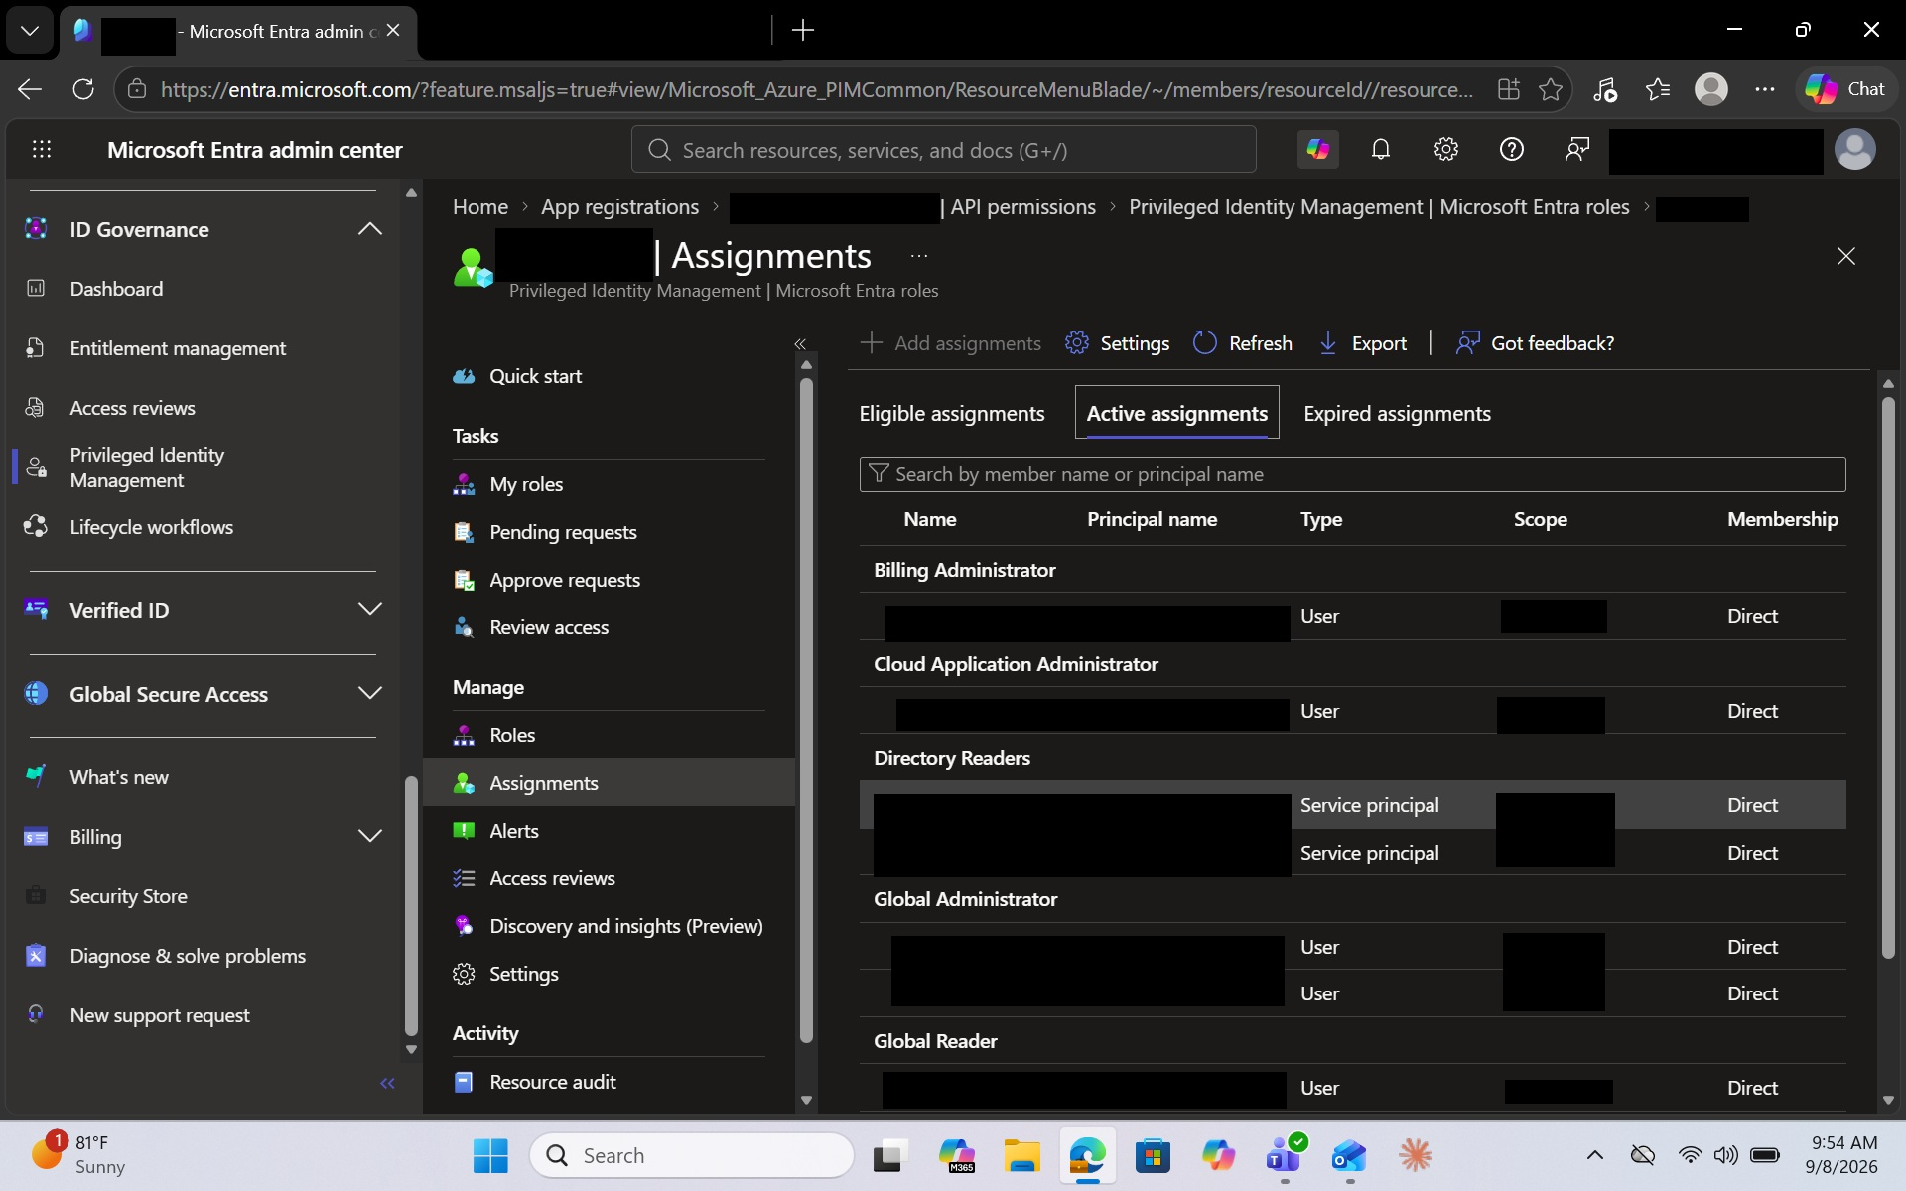
Figure 3 – Microsoft Entra role assignments managed through PIM
Figure 3 demonstrates centralized visibility into privileged Microsoft Entra role assignments. Administrators can identify the role, principal type, scope, and membership relationship associated with privileged access.

4. Controlling How Privilege Is Activated
Eligibility alone is not the complete control. PIM allows organizations to define conditions that must be satisfied when an administrator activates privilege.
- Maximum activation duration
- Multifactor authentication
- Business justification
- Ticket information
- Approval
- Eligible-assignment expiration
- Active-assignment expiration

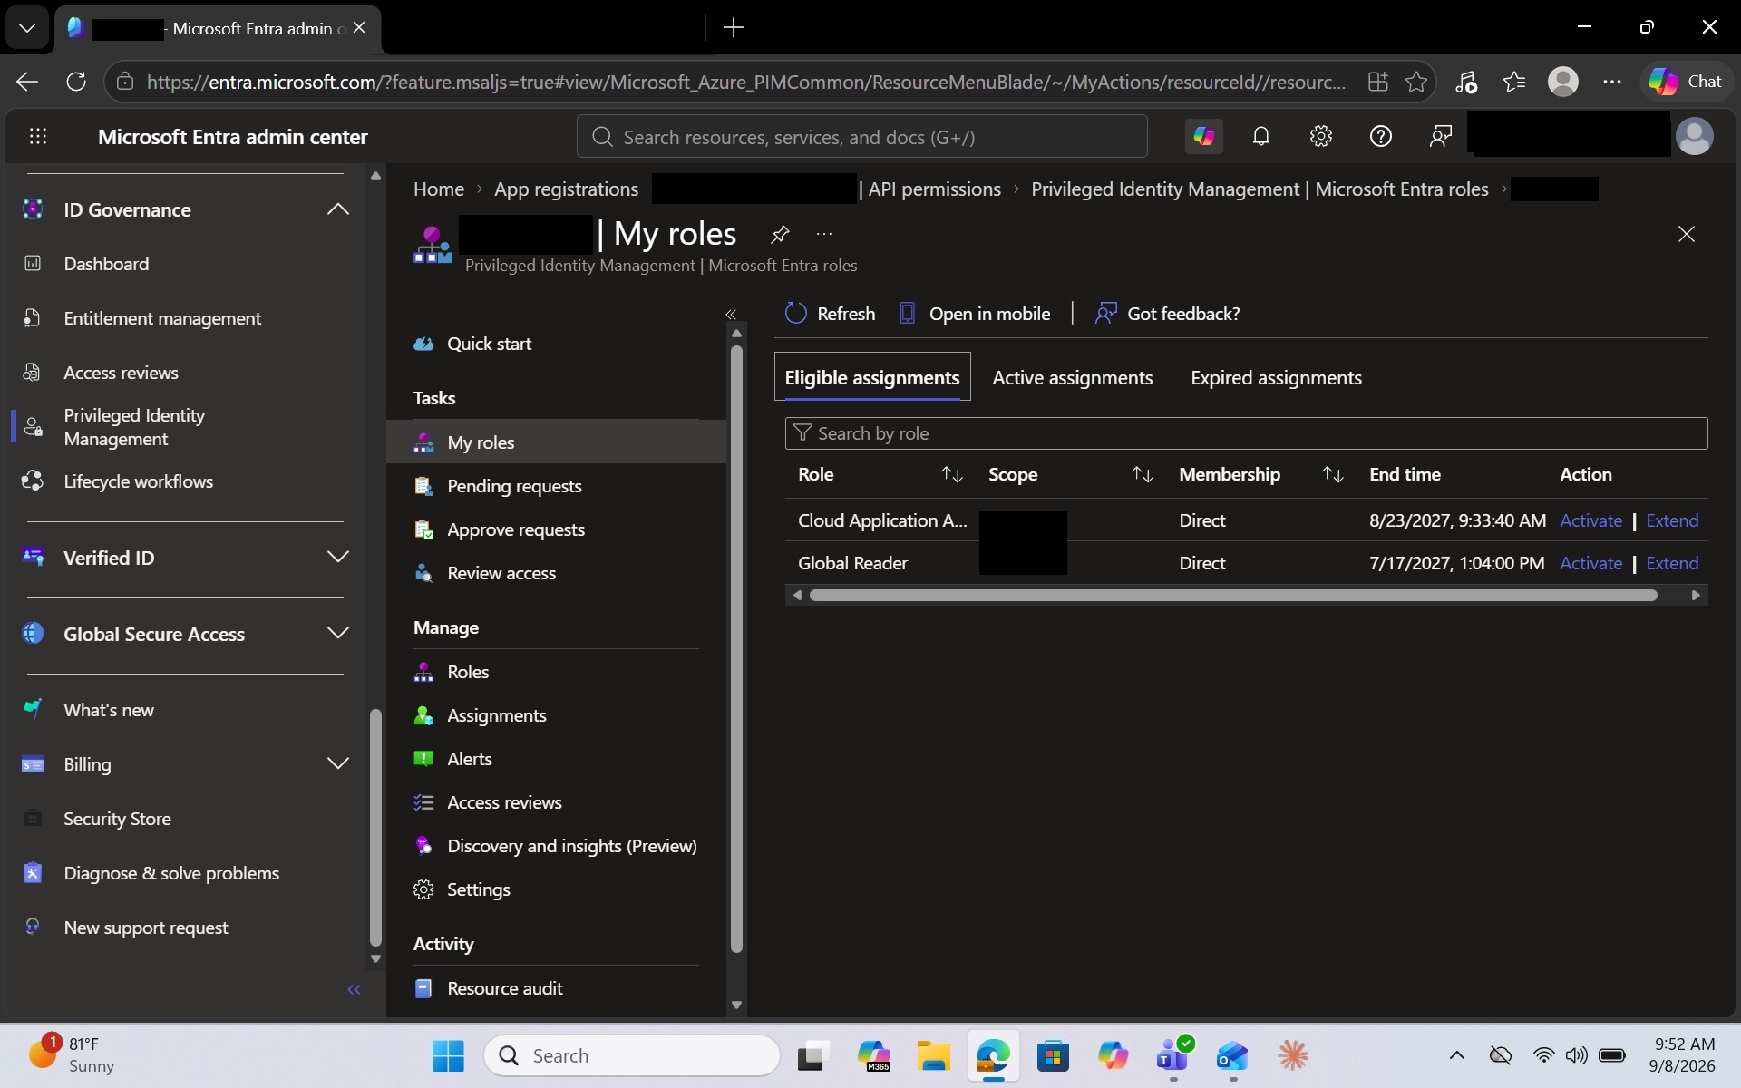
Figure 4 – Example PIM activation controls for a privileged role

Figure 4 demonstrates configurable activation controls for a highly privileged Microsoft Entra role. These controls reduce risk by limiting how and when privileged authorization can become active.

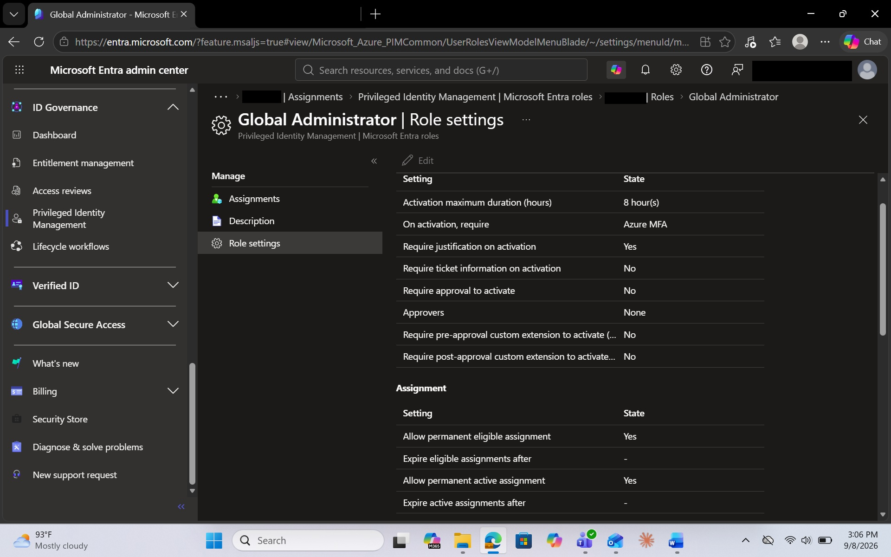
Figure 5 – PIM role assignment and activation policy settings

Figure 5 demonstrates that PIM policies can also govern whether eligible or active assignments may be permanent and what additional requirements apply. This provides granular governance over the authorization lifecycle.

5. Just-in-Time Activation in Practice
The practical value of PIM becomes especially clear during role activation. An administrator who has an eligible role can request activation only when administrative privileges are required.
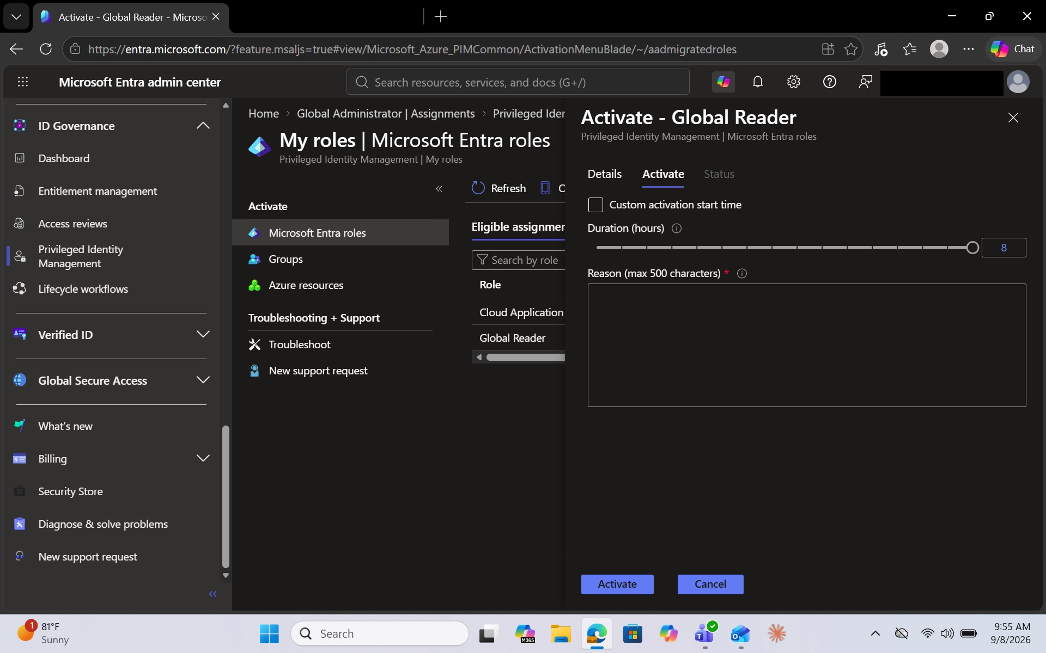
Figure 6 – Just-in-time activation of an eligible Microsoft Entra role
Figure 6 shows an eligible Global Reader role being prepared for activation. The administrator selects an activation duration and can be required to provide a business justification before receiving the role. The security model is straightforward: privilege exists when needed rather than remaining permanently active

6. Verification of Temporary Privilege
After activation, the role moves from eligible to active for the permitted period.

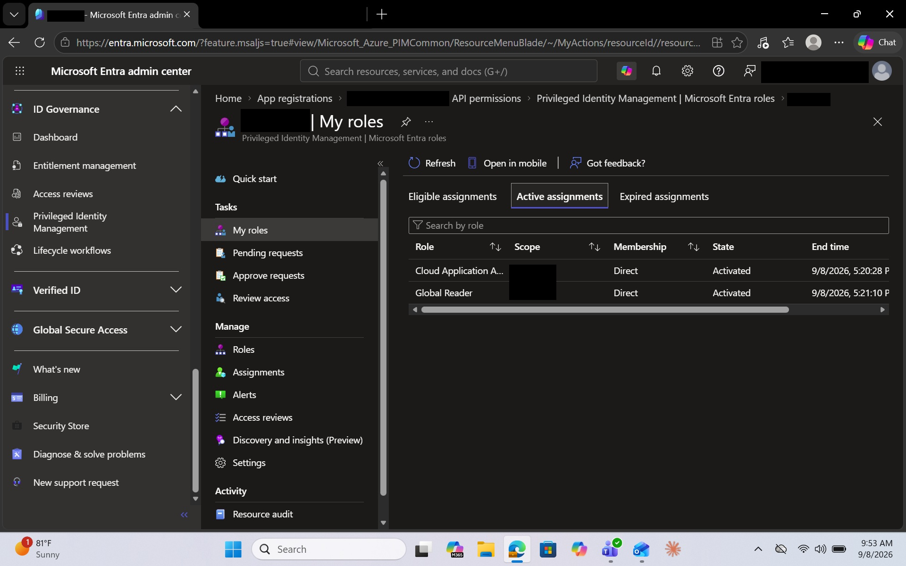
Figure 7 – Temporarily activated Microsoft Entra roles

Figure 7 confirms that the eligible roles became active and received defined expiration times. This demonstrates the benefit of just-in-time administration: privileged authorization can automatically cease when the activation window expires.

7. PIM Auditing
Privileged authorization also requires accountability. PIM records activity associated with privileged-role management, allowing administrators and security teams to review role-related events.

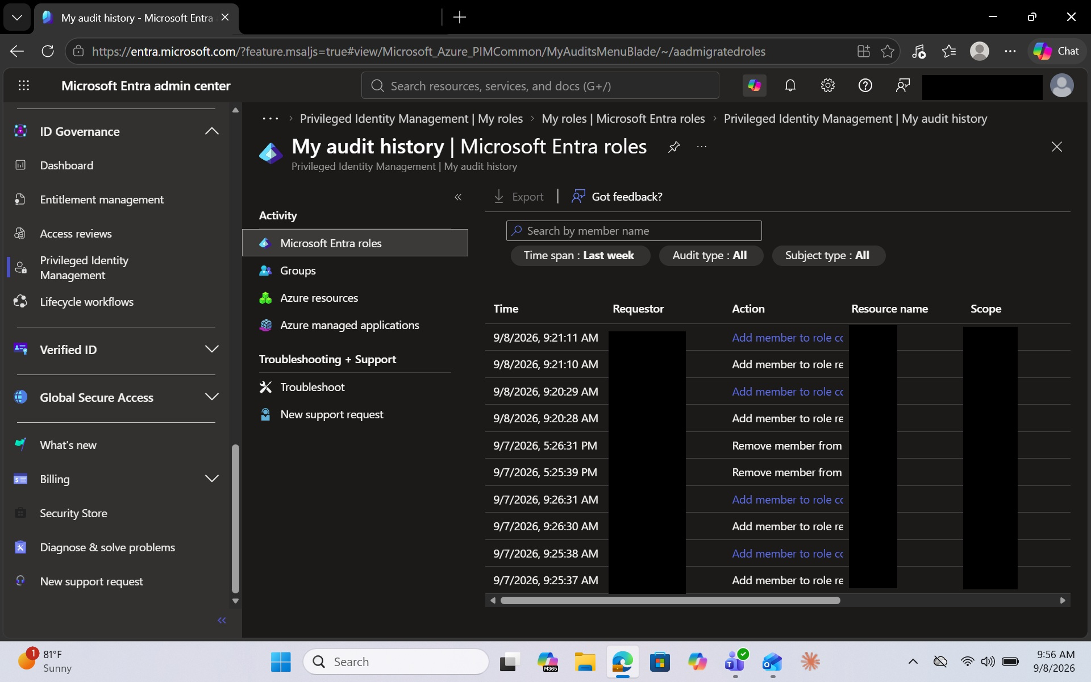
Figure 8 – Microsoft Entra PIM privileged-role audit history

Figure 8 demonstrates PIM auditing for privileged-role activity. Events associated with role membership and privileged access can be reviewed to support investigation, governance, and compliance.
Observed PIM lifecycle: Eligible → Activate → Use privilege → Expire → Audit

8. Where the PIM-Only Model Becomes Incomplete
The next question is the most important one for organizations evaluating PAM: what happens when the privileged resource is not simply a human administrator activating an Entra role?
Applications, automation processes, services, scheduled jobs, and infrastructure components may need elevated access without a person manually activating a role each time.

As shown previously in Figure 3, PIM active assignments can include non-human identities such as service principals. This demonstrates that privileged access is not limited to interactive human administrators.

PIM can govern supported role assignments, but privileged-access risk does not end with the assignment itself. Organizations must also ask: Where is the credential stored? Who can retrieve it? When was it last changed? Can it be automatically rotated? Can access be checked out? What happens after use? These questions move into privileged credential management.

9. What PAM Adds
The PAM portion of the walkthrough examines a privileged account stored as a protected secret. PAM controls the underlying credential in addition to controlling access to it.
- Credential vaulting
- Secret-level permissions
- Credential checkout and check-in
- Automated password rotation
- Remote password changing
- Credential-access auditing
- Dependency management

10. Secret-Level Access Control
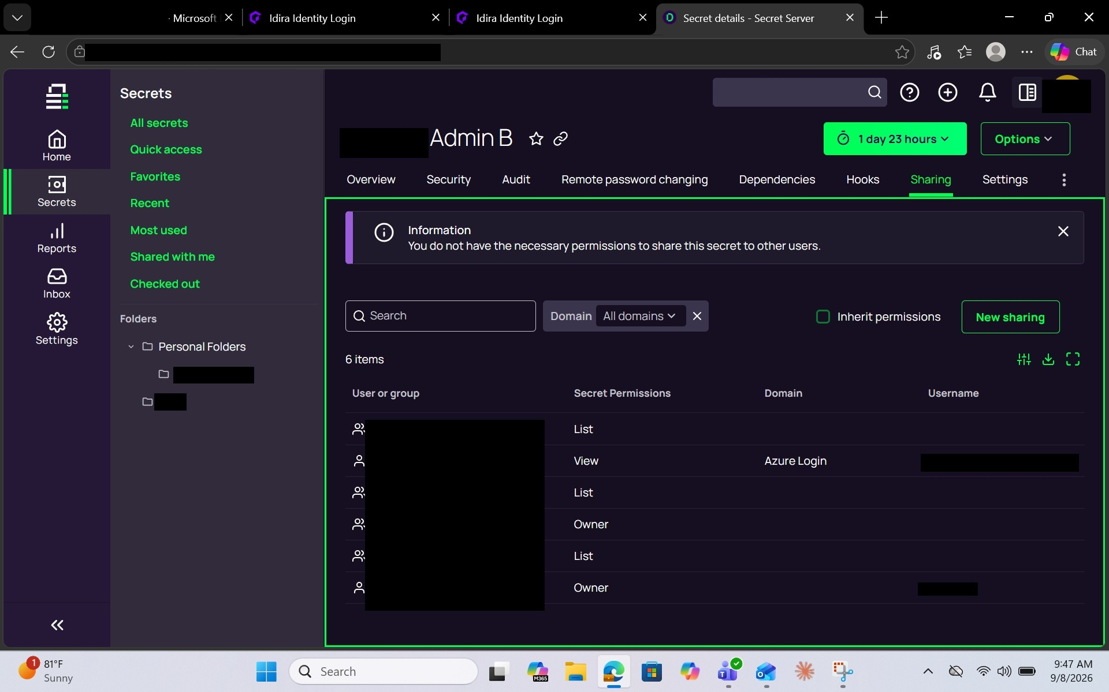
Figure 10 – PAM secret-level access permissions

Figure 10 demonstrates access control applied directly to a privileged secret. Permissions determine which authorized users or groups can interact with the credential. The control is applied to the credential stored within the privileged-access vault itself, rather than only to an Entra role.
If Entra roles, conditional access policies and more are not acutely setup properly in Microsoft Entra and or managing a large deeply rooted environment Microsoft PIM can get complicated. Whereas in a PAM solution you are managing but the secret and the account to be focused on and watched.

11. Credential Checkout and Post-Use Rotation

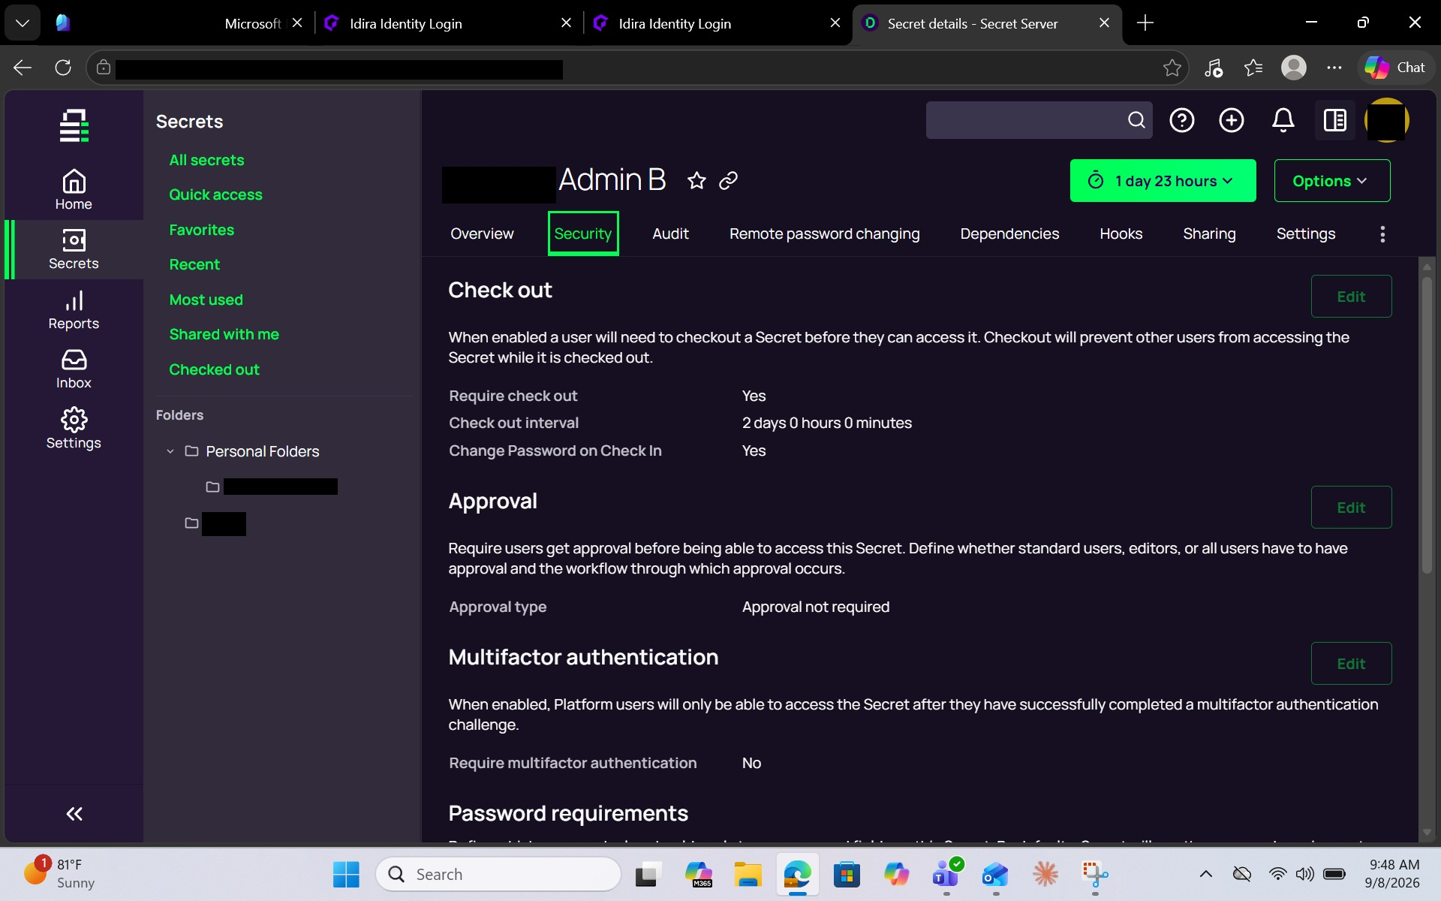

Figure 11 – PAM credential checkout and password change on check-in

Figure 11 demonstrates a control over the lifecycle of the privileged credential itself. Requiring checkout creates a controlled use period, while changing the password on check-in helps prevent reuse of the same privileged credential after authorized access ends.

Session recording is also offered here in case of use of incident response or deeper audit controls pending the nature of the environment.

12. Automated Password Rotation

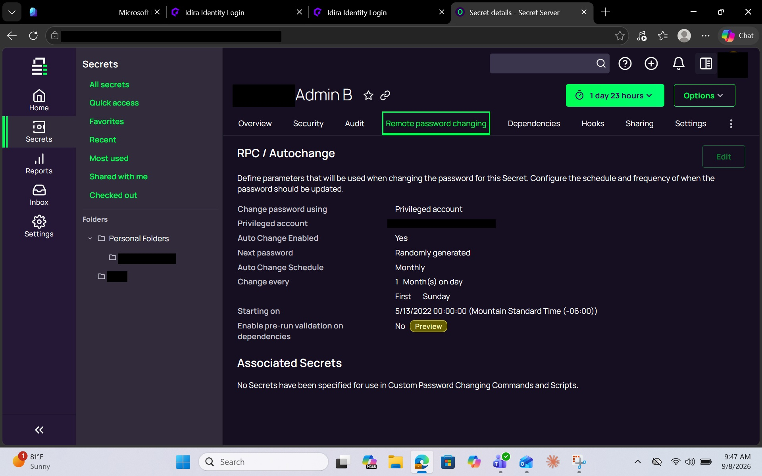
Figure 12 – Automated privileged password rotation using PAM

Figure 12 demonstrates automatic password management for the privileged account. Automated rotation reduces reliance on manual password-change processes and reduces the usable lifetime of a compromised or previously exposed credential.
This of course is very important in service accounts, machine accounts and more where often time the owners of these accounts are unidentified and unknown. Passwords must be setup to rotate automatically to avoid stale & compromise.

13. PAM Audit Trail
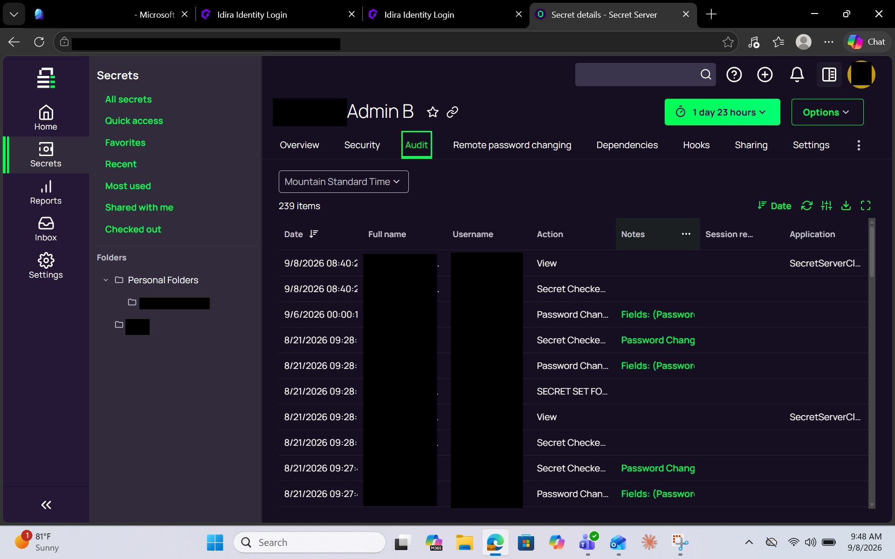
Figure 13 – PAM privileged-secret audit history

Figure 13 demonstrates audit history associated with the privileged secret. This provides accountability at the credential-use level and complements the role-assignment and activation auditing provided by PIM.

14. Credential Dependencies

Password rotation introduces another operational consideration. A privileged credential may be consumed by another system, service, application, or automated process. Changing the password without accounting for those dependencies can disrupt the dependent workload.

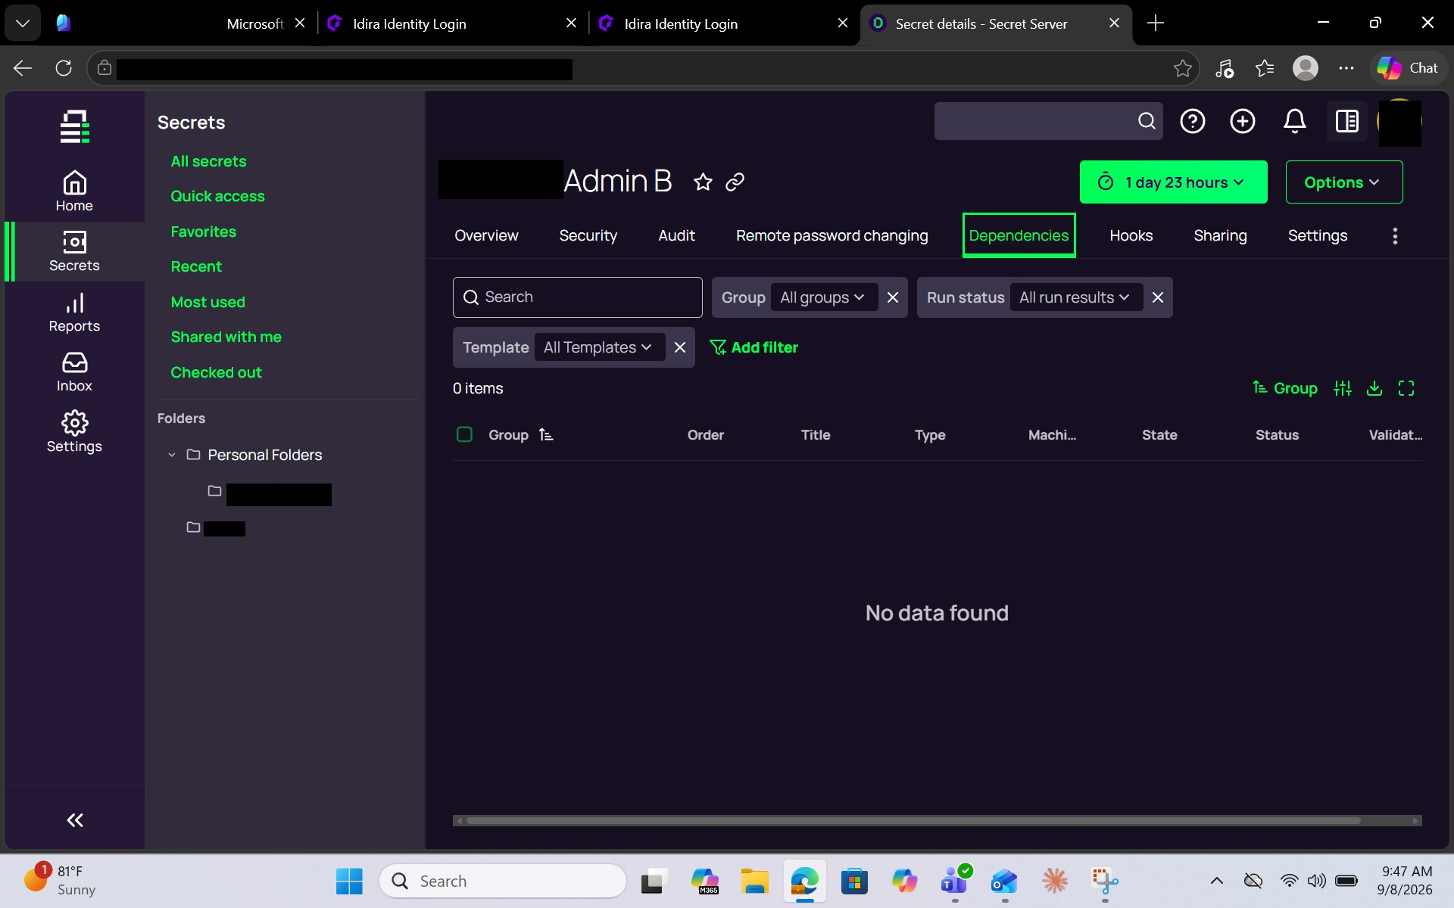
Figure 14 – PAM privileged credential dependency management

Figure 14 shows the dependency-management area associated with the privileged secret. Even where no dependencies are configured in the example, the capability illustrates why service and application credentials require lifecycle controls beyond interactive role activation.

Dependencies indeed can be complicated but same, would rather define the dependencies while setting up and configuring PAM solution rather then via a compromise when you are looking back to the logs at all that were initially blindly affected.

15. Privileged Secret Overview and Configuration
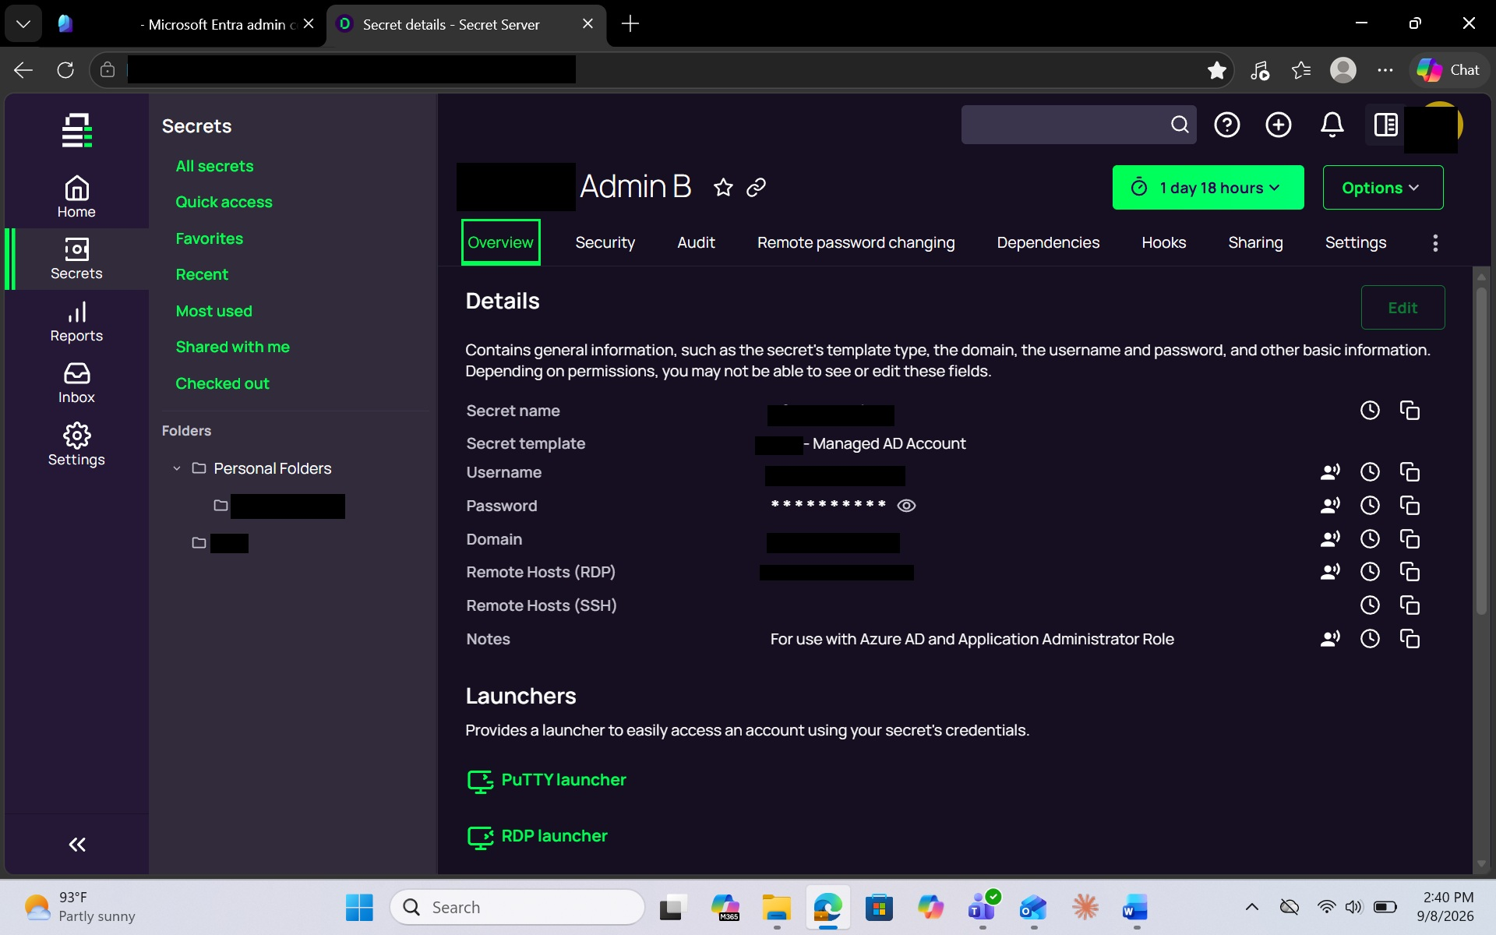
Figure 15 – PAM management of a privileged account as a protected secret
Figure 15 provides the overall privileged-secret context for the PAM controls demonstrated above. Rather than granting only authorization to a role, PAM manages the underlying privileged account or secret throughout its lifecycle.

16. What the Testing Demonstrated
The practical testing highlights an architectural distinction: PIM is strongest at privileged authorization governance, while PAM extends control into the privileged credential lifecycle.
Capability | Microsoft Entra PIM | PAM
Eligible privileged-role assignments | Yes | Not primary purpose
Just-in-time role activation | Yes | Can complement
Time-bound role access | Yes | Can complement
MFA during role activation | Yes | Platform dependent
Activation justification / approval | Yes | Platform dependent
Privileged-role auditing | Yes | Can complement
Privileged credential vaulting | Not PIM's primary function | Yes
Credential checkout / check-in | Not PIM's primary function | Yes
Automatic password rotation | Not PIM's primary function | Yes
Password change after credential use | Not PIM's primary function | Yes
Secret-level access permissions | Not PIM's primary function | Yes
Credential dependency management | Not PIM's primary function | Yes
Credential-access audit trail | Not PIM's primary function | Yes
Shared/service privileged account management | Different / limited scope | Core PAM use case
The conclusion is not that one technology is stronger than the other. They protect different layers of privileged access.

17. Practical Use Cases

Scenario A – Human Entra Administrator
An engineer occasionally requires a privileged Microsoft Entra role. A preferred flow is:

Eligible role → Request activation → Satisfy controls → Temporary role → Perform work → Role expires → Audit
This is an excellent PIM use case and is demonstrated in Figures 1–9.

Scenario B – Privileged Service or Administrative Account
An application, scheduled process, infrastructure component, or administrator requires access to a privileged account whose credential must be protected. A preferred flow is:
Vault credential → Restrict access → Checkout → Use → Check in → Rotate → Update dependencies → Audit
This is a PAM use case and is demonstrated in Figures 10–15.

18. Why PIM Alone May Not Be Enough
An organization can implement PIM successfully and still retain privileged credential risk. PIM can reduce the amount of time a human administrator holds an Entra role, but that does not by itself mean every privileged service-account password is vaulted, every shared administrative credential is automatically rotated, or every privileged secret is checked out and invalidated after use.
Likewise, deploying PAM without eliminating unnecessary standing Entra administrative assignments leaves another category of privileged-access risk unresolved.
PIM minimizes standing authorization. PAM minimizes standing credential exposure.

19. Recommended Control Model
Organizations using Microsoft Entra PIM should continue using PIM as the primary control for supported Microsoft Entra and Azure privileged-role activation. PIM should favor eligible rather than unnecessary permanently active assignments, apply appropriate activation durations, require MFA for sensitive privilege activation, require justification where appropriate, use approval for higher-risk roles where operationally practical, and periodically review privileged assignments.
PAM should complement those controls for privileged credentials and accounts that require vaulting or credential lifecycle management. High-value PAM candidates include:
- Shared administrative credentials
- Privileged local or domain accounts where applicable
- Service accounts
- Application or automation credentials
- Infrastructure credentials
- Credentials requiring automatic rotation
- Credentials requiring checkout/check-in
- Secrets that must be individually audited
- Credentials with downstream dependencies
The objective is not to force every privileged identity into one technology. The objective is to apply the appropriate control to each type of privileged access.

20. Key Takeaway
Because activating privilege and protecting privileged credentials are not the same security problem.
Microsoft Entra PIM provides strong just-in-time governance over privileged role authorization. It determines who can become privileged, under what conditions, and for how long.
PAM extends privileged-access protection to the credentials and accounts themselves. It can determine who can access a privileged credential, how it is stored, when it is rotated, whether it must be checked out, what happens after use, and how credential activity is audited.
PIM: Eligible → Activate → Temporary privilege → Expire → Audit
PAM: Vault → Control → Checkout → Use → Rotate → Audit
For organizations with both human administrators and privileged non-human or credential-based identities, these capabilities are complementary rather than redundant. PIM reduces standing privilege; PAM reduces standing credential exposure. Together, they provide a more complete privileged-access security model.

21. Ways to Enforce PAM & PIM into Work Culture
If a user wants to get around PAM they can simply change their own work email password and get into the PAM. And PIM can be complicated pending how invested are in Microsoft and how granular current roles, applications integrated etc. Important not just to start these products and processes but also to have them being used!
- Executive Sponsorship – LEADERSHIP visibly use PIM and PAM themselves, reference it. CARE.
- Enforce Conditional Access requiring Phishing Resistant MFA on the PAM application itself independent of the directory password
- Bake it into Onboarding
- Make the secure path the easy path
- Gamification. Recognize teams with 100% PAM compliance
- Just in Time by Default. Standing access by exception
- Post incident Story Telling. Talk about mistakes and wins
- Integrate into change management

Appendix A – Screenshot Insertion Checklist
Use this checklist while inserting the final redacted images. In Word, click the placeholder area, delete the placeholder table, then use Insert > Pictures > This Device. Select the corresponding redacted image, choose Layout Options > In Line with Text, center the image, and keep its aspect ratio. Target approximately 6.2–6.5 inches wide. Leave the figure caption immediately below the image.
# | Section | Screenshot to insert | Status
1 | PIM Quick Start | Quick Start page showing Assign / Activate / Approve / Audit | ☐ Inserted
2 | Eligible assignments | PIM Assignments page with Eligible assignments selected | ☐ Inserted
3 | Role assignment inventory | Assignments view showing administrative roles | ☐ Inserted
4 | Global Administrator activation settings | Role settings showing activation duration/MFA/justification/approval | ☐ Inserted
5 | Global Administrator assignment settings | Role settings showing assignment policy controls | ☐ Inserted
6 | Activate Global Reader | Activation pane with duration and reason | ☐ Inserted
7 | Active assignments | My roles showing activated roles and end times | ☐ Inserted
8 | PIM audit history | My audit history with timestamped role events | ☐ Inserted
9 | Service principal assignment | Assignments view where Type includes Service principal | ☐ Inserted
10 | PAM Sharing | Admin B Sharing / permissions | ☐ Inserted
11 | PAM Security | Checkout and Change Password on Check In | ☐ Inserted
12 | PAM Remote Password Changing | Autochange / password rotation configuration | ☐ Inserted
13 | PAM Audit | Secret-level audit history | ☐ Inserted
14 | PAM Dependencies | Dependencies tab | ☐ Inserted
15 | PAM Secret Overview | Remaining Admin B overview/configuration screenshot | ☐ Inserted

Appendix B – Suggested Authoritative References
Before external publication, validate the latest Microsoft and PAM-vendor documentation and update links/titles as needed. Suggested reference topics:
- Microsoft Learn – Microsoft Entra Privileged Identity Management overview
- Microsoft Learn – Assign Microsoft Entra roles in Privileged Identity Management
- Microsoft Learn – Activate Microsoft Entra roles in Privileged Identity Management
- Microsoft Learn – Configure Microsoft Entra role settings in PIM
- Delinea Secret Server documentation – Secret checkout
- Delinea Secret Server documentation – Remote password changing / automatic password rotation
- Delinea Secret Server documentation – Secret audit logs
- Delinea Secret Server documentation – Dependencies

